**To separate csv & txt files load into two different data base**

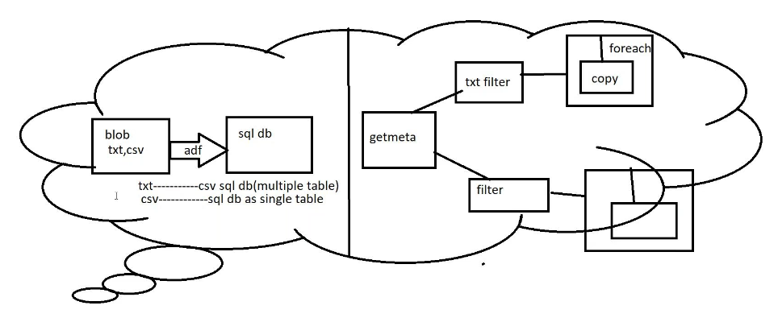

Create blob storage :upload txt files and csv files

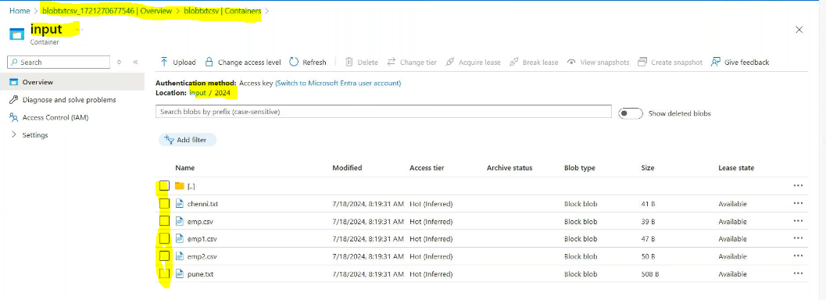

Need to maintain the same schema in txt & csv files

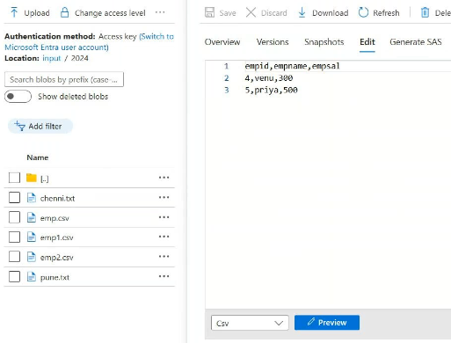

Create 2 sql database 1 is csv files databases other 1 is txt files sql databases by using same same server

csvfilessqldatabes

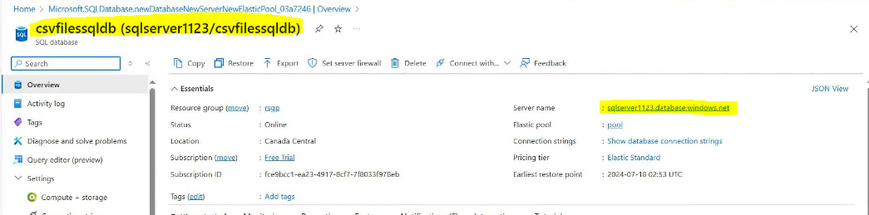

txtfilesqldatabase:

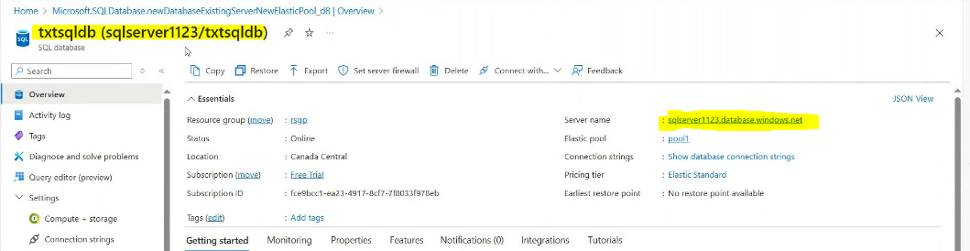

Create a 3 linked services for 1 for blob or source side 1 for sqlcsv sink side and 1 for sqltxt sink side

Create a linked service for blob or source:

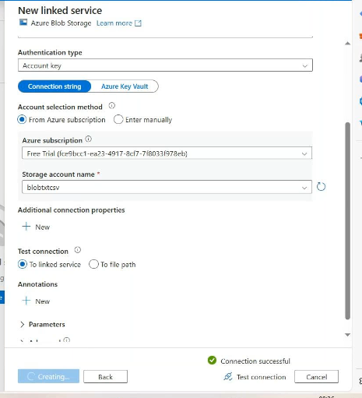

Create a linked service for sqlcsv_sink in sql:

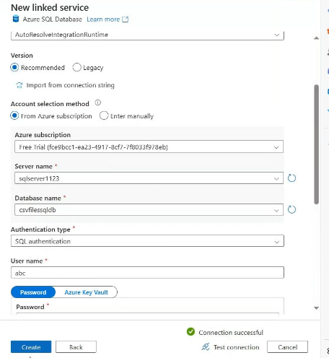

Create a linked service for sqltxt_sink in sql:

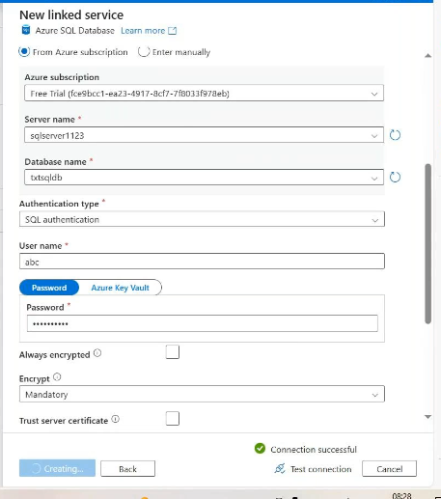

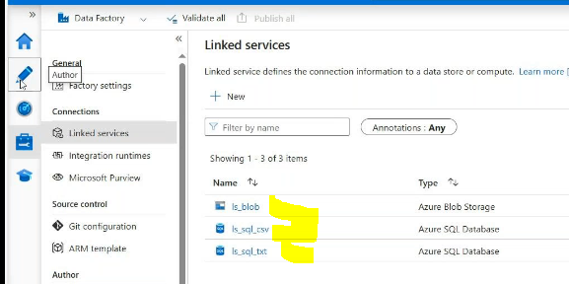

Create 3 data sets 1 for source side or blob, 1 for txt_sink, 1 for csv_sink

Source side dataset:

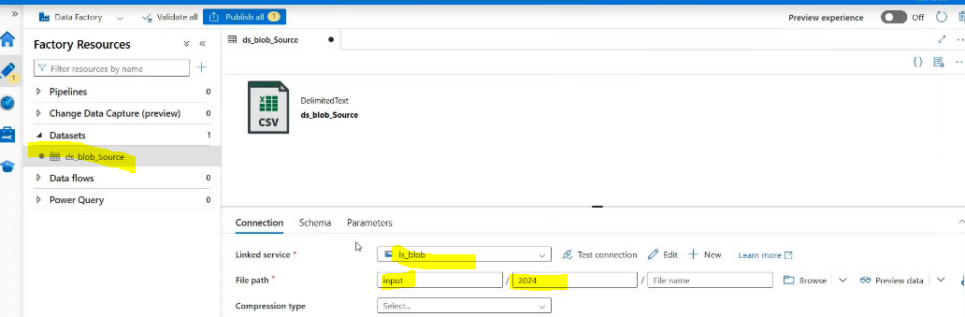

Csv_sinkside dataset:

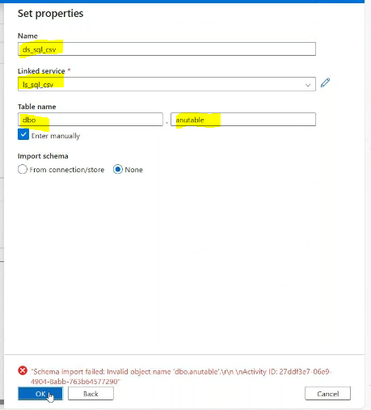

Txt sink_side dataset: for txt i want create multiple table that’s way table name is empty

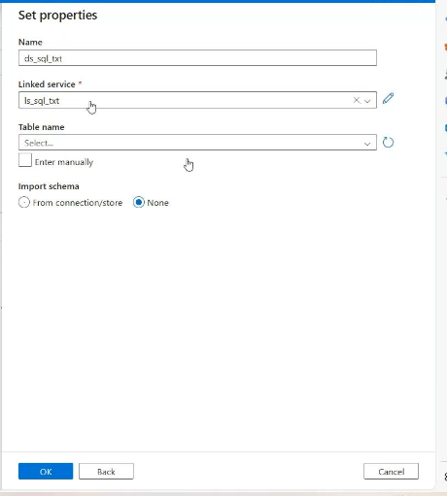

Create pipeline: drag get metadata activity fro get metadata activity need to create 1 dataset

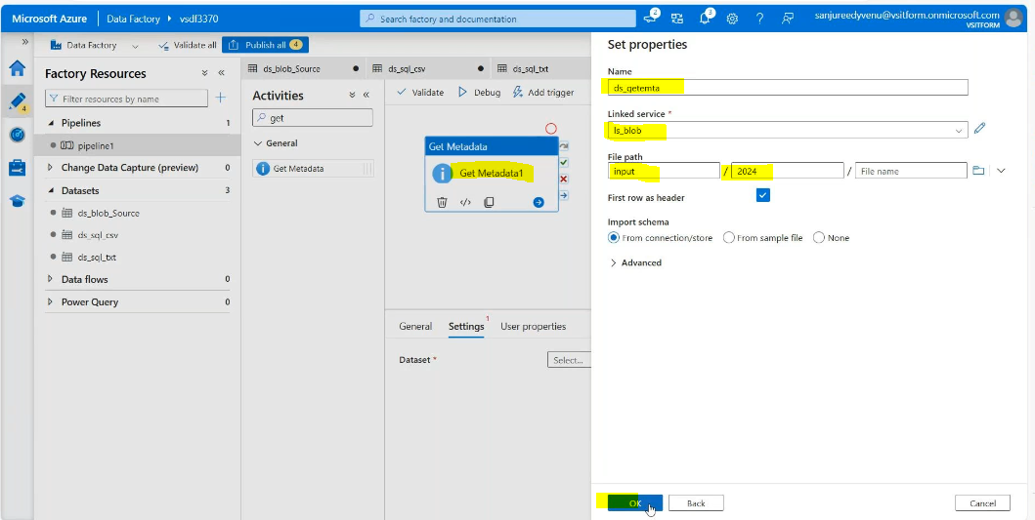

Then add child times and validate and debug it :

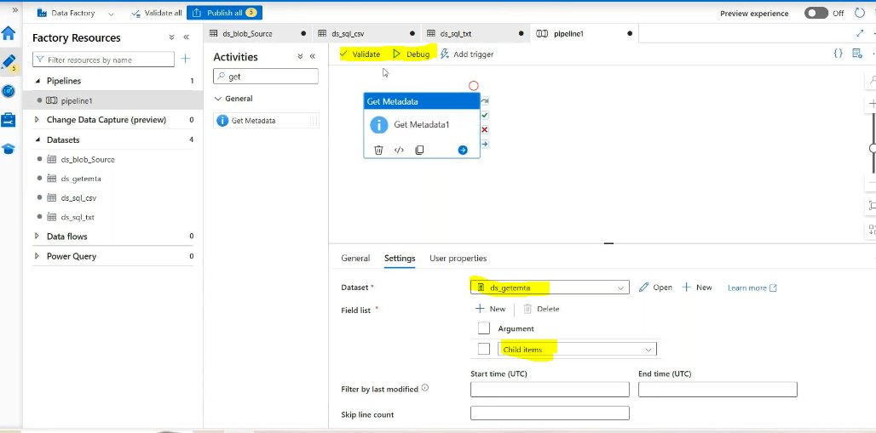

Getting the all files information:

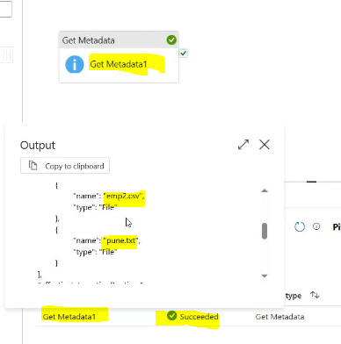

Then add the filter activites 1 for txt_filter 1 fro csv_filter

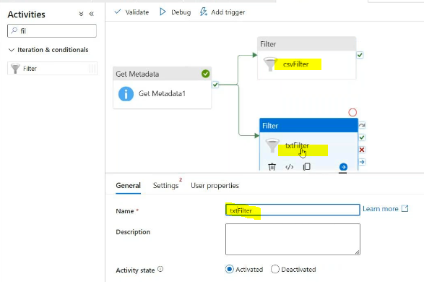

Then go to csv_filter activity🡪settings🡪items🡪add dynamic content

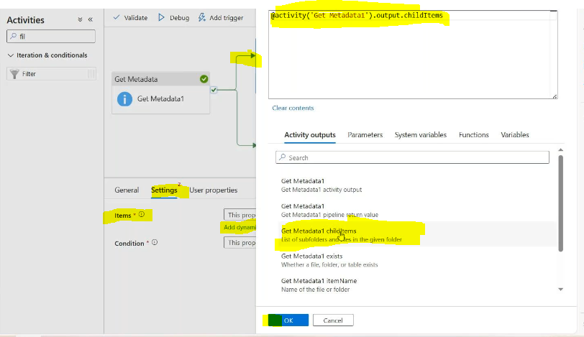

Then go to csv_filter activity🡪settings🡪condition🡪add dynamic content

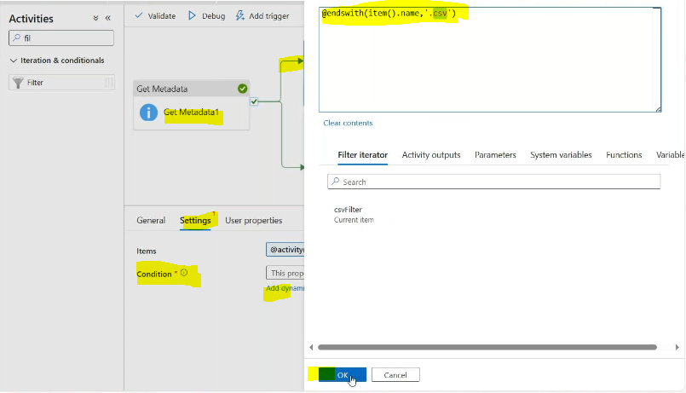

Like this:

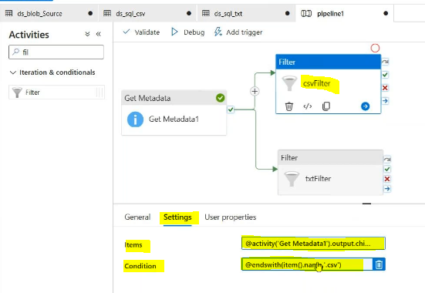

Then go to txt_filter activity🡪settings🡪items🡪add dynamic content

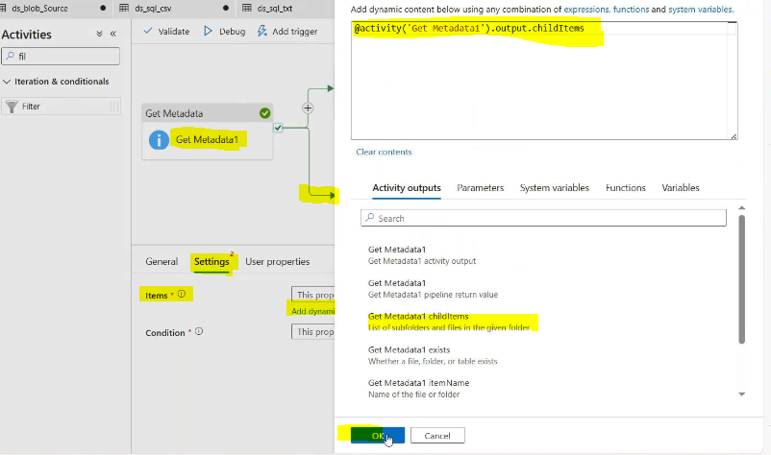

Then go to txt_filter activity🡪settings🡪condition🡪add dynamic content

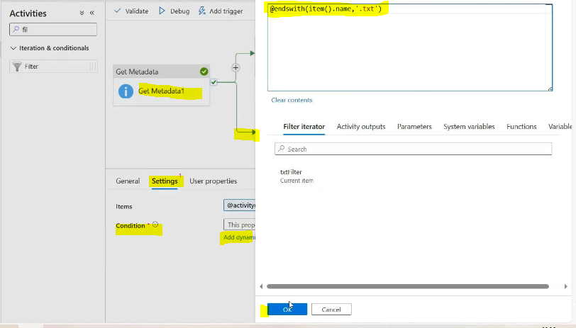

Like this:

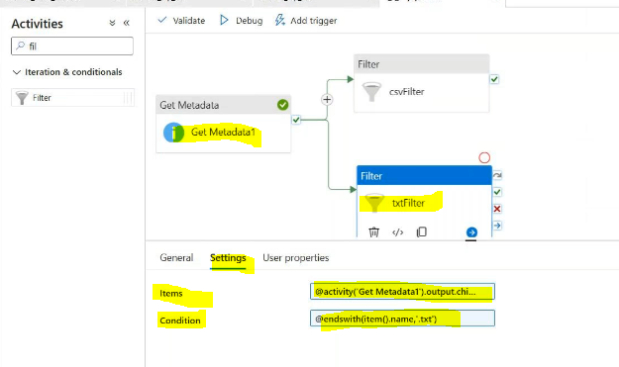

Validate & debug:

Csv filter: it filter the csv files

Txt filter: it filter the txtx files

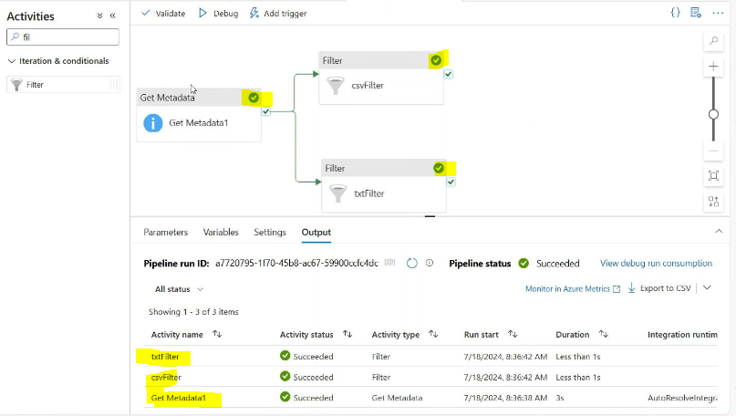

Then take the foreach for both txt and csv file and named it for both

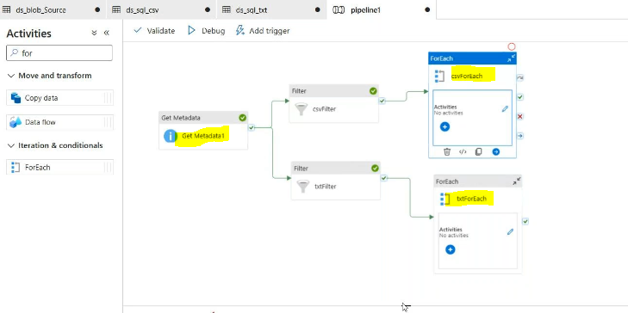

Then select the csv foreach🡪settings🡪items🡪adddynamic🡪select csvfilter activity

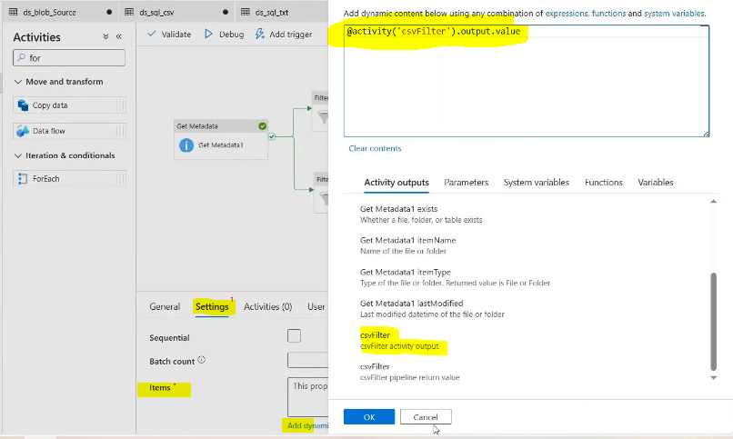

Then select the txt foreach🡪settings🡪items🡪adddynamic🡪select txtfilter activity

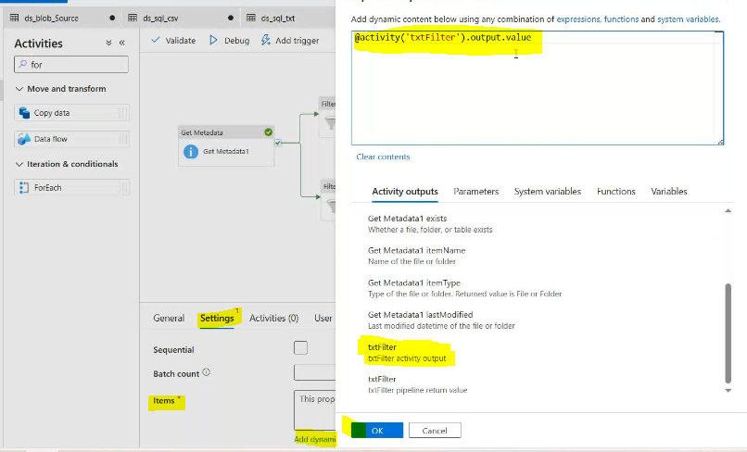

Then drag the copy data activity in csv foreach ans txt foreach activity

Highlight copt data activity in csvforeach🡪add sourcedtaset

But we need to parameter for this data set then open the dataset

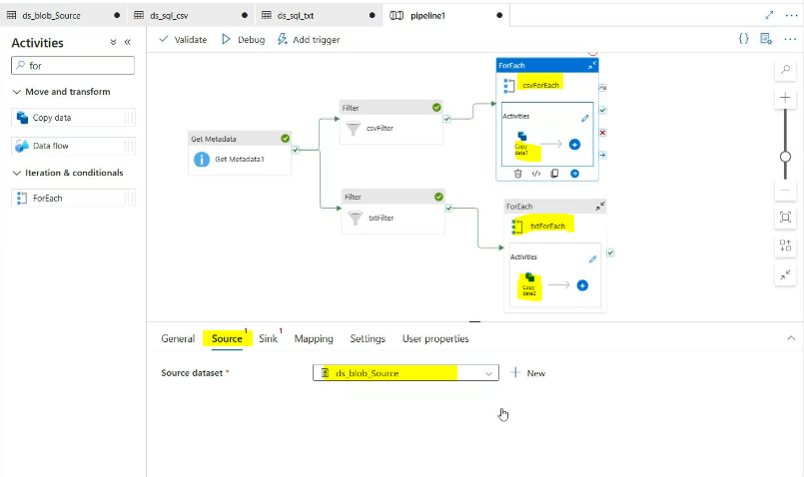

Open the blob dataset for source side:  
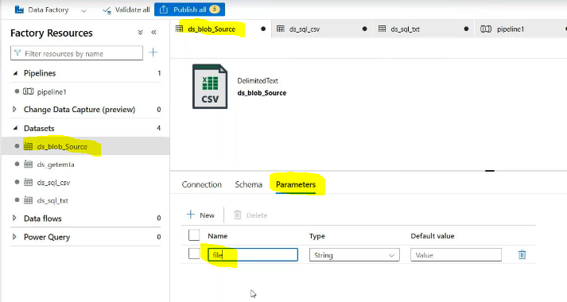

Conneetion:

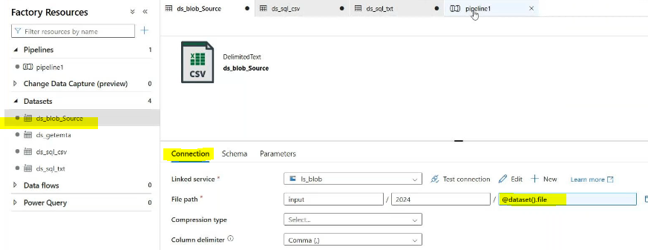

In pipe line level:

Csv foreach copy data activity source side:

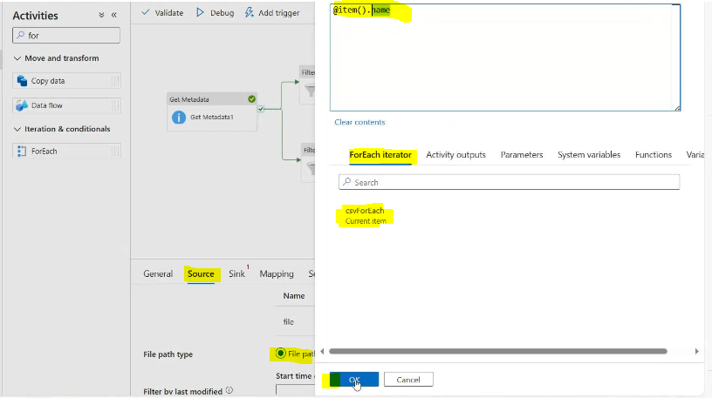

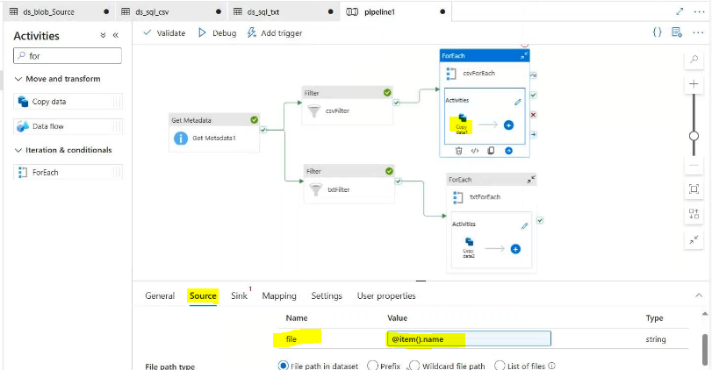

Csv foreach copy data activity sink side:

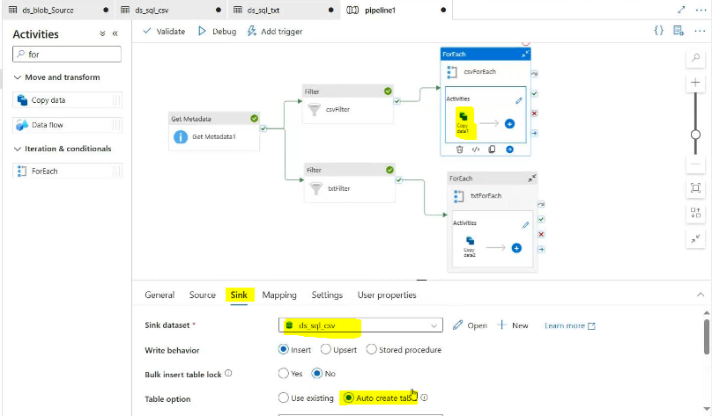

Txt_foreach copy data activity source side:

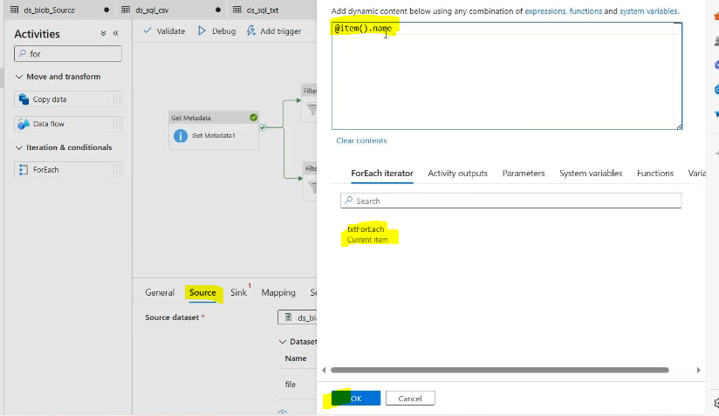

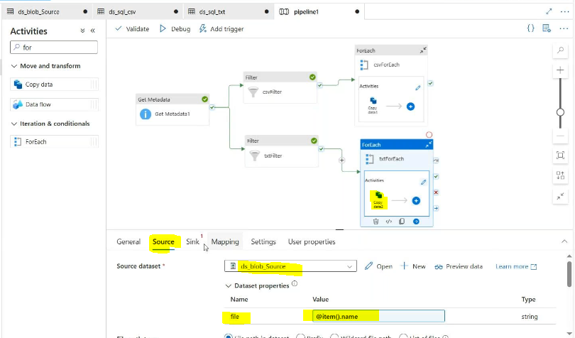

Sink side:  
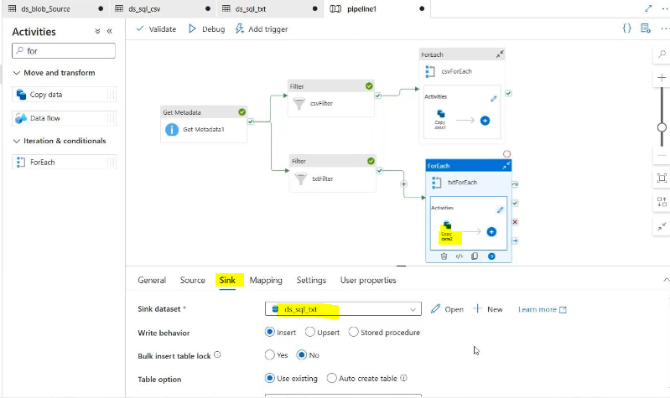

Openthe sink side sql data set: need to be create parameters

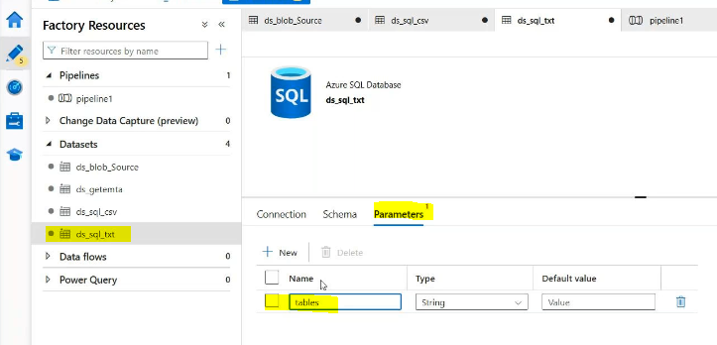

Connection:add dynamic value in Table

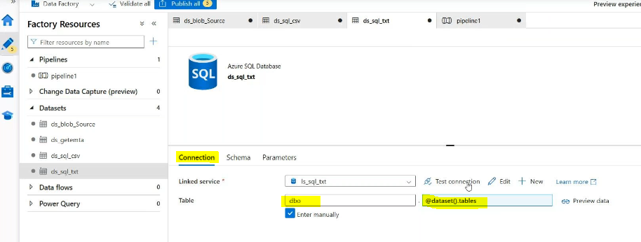 inpipeline level:

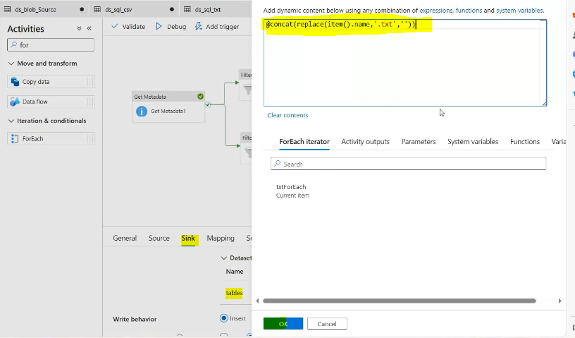

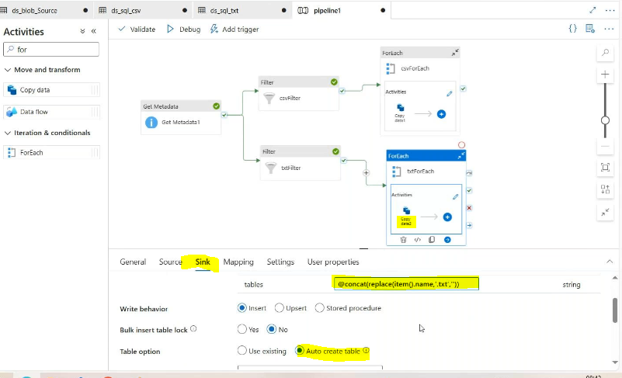

Validate and debug

Result :

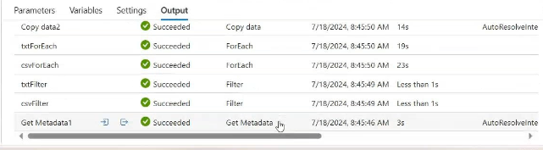

Go to csv filte sql database

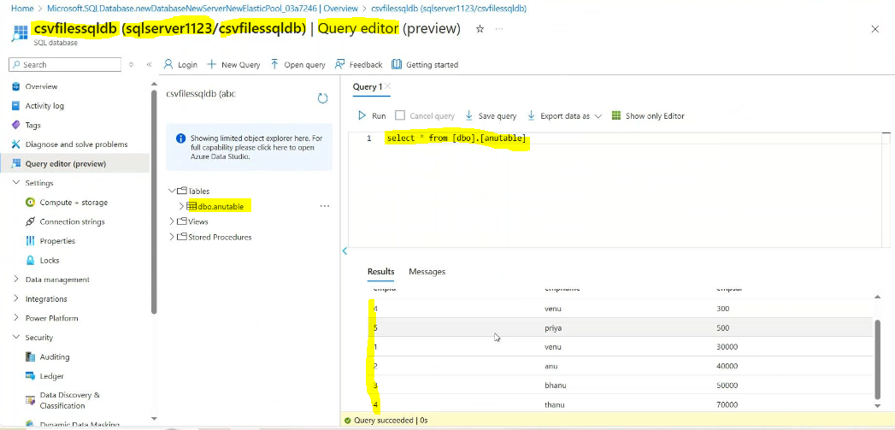

Go to the txtfile sql data base

